### 

### Semester Two Examination, 2019

### Question/Answer booklet

# Yr 12 SPECIALIST

**UNIT 3 & 4**

## Section Two:

## Calculator-assumed

|  |
| --- |

Your Name

Your Teacher’s Name

## Time allowed for this section

Reading time before commencing work: ten minutes

Working time: one hundred minutes

## Materials required/recommended for this section

***To be provided by the supervisor***

This Question/Answer booklet

Formula sheet (retained from Section One)

***To be provided by the candidate***

Standard items: pens (blue/black preferred), pencils (including coloured), sharpener, correction fluid/tape, eraser, ruler, highlighters

Special items: drawing instruments, templates, notes on two unfolded sheets of A4 paper, and up to three calculators approved for use in this examination

## Important note to candidates

No other items may be taken into the examination room. It is **your** responsibility to ensure that you do not have any unauthorised material. If you have any unauthorised material with you, hand it to the supervisor **before** reading any further.

| **Question** | **Marks** | **Max** | **Question** | **Marks** | **Max** |
| --- | --- | --- | --- | --- | --- |
| **8** |  | **4** | **15** |  | **9** |
| **9** |  | **8** | **16** |  | **8** |
| **10** |  | **9** | **17** |  | **8** |
| **11** |  | **7** | **18** |  | **9** |
| **12** |  | **7** | **19** |  | **7** |
| **13** |  | **7** | **20** |  | **7** |
| **14** |  | **10** |  |

**Structure of this paper**

| Section | Number of questions available | Number of questions to be answered | Working time (minutes) | Marks available | Percentage of examination |
| --- | --- | --- | --- | --- | --- |
| Section One:  Calculator-free | 7 | 7 | 50 | 51 | 34 |
| Section Two:  Calculator-assumed | 13 | 13 | 100 | 100 | 66 |
|  |  |  |  | **Total** | 100 |

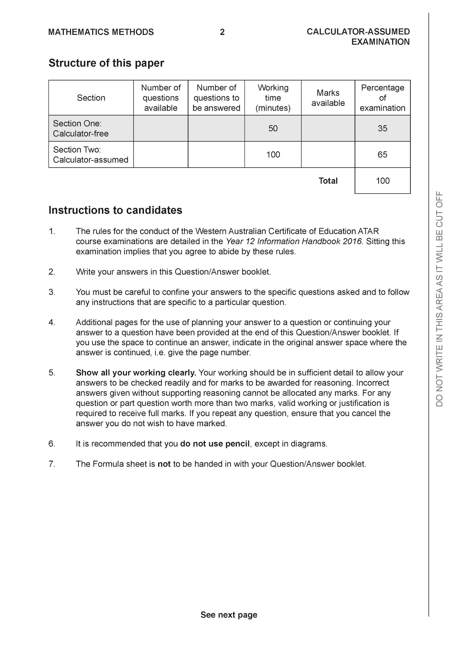

**Section Two: Calculator-assumed (100 Marks)**

This section has **13** questions. Answer **all** questions. Write your answers in the spaces provided.

Spare pages are included at the end of this booklet. They can be used for planning your responses and/or as additional space if required to continue an answer.

● Planning: If you use the spare pages for planning, indicate this clearly at the top of the page.

● Continuing an answer: If you need to use the space to continue an answer, indicate in the original answer space where the answer is continued, i.e. give the page number. Fill in the number of the question that you are continuing to answer at the top of the page.

Working time: 100 minutes.

**Question 8 (4 marks)**

Consider the complex number . By using De Moivre’s theorem show that



| **Solution** |
| --- |
|  |
| **Specific behaviours** |
| ✓ sets up equation for cis  ✓ uses De Moivre’s for one side  ✓ expands binomial expression for other side  ✓ equates real parts of both sides |

**Question 9 (8 marks)**

Sketch the following regions in the complex plane.

1. (2 marks)



| **Solution** |
| --- |
|  |
| **Specific behaviours** |
| ✓ draws line firmed in  ✓ shades region |

1. (2 marks)



| **Solution** |
| --- |
|  |
| **Specific behaviours** |
| ✓ dotted circle of correct centre and radius  ✓ shaded region outside circle |

Q9 Cont-

The solution to , where are real constants, is given by .



1. Determine the exact values of . (4 marks)



| **Solution** |
| --- |
|  |
| **Specific behaviours** |
| ✓ sets up equation for unknowns using gradient of perpendicular  ✓ sets up equation for midpoint using given line  ✓ solves for a exactly  ✓ solves for b exactly |

**Question 10 (9 marks)**

Consider an electronics company that manufactures transistors with weights that forms a Normal distribution of mean 95 milligrams and a standard deviation of 23 milligrams. A sample of 75 transistors is taken and the sample mean weightof this sample of 75 is examined.



1. State the distribution with its mean and standard deviation. (3 marks)



| **Solution** |
| --- |
|  |
| **Specific behaviours** |
| ✓ states Normal  ✓gives mean  ✓ gives standard deviation (un-simplified) |

1. Determine the probability that the sample mean is greater than 102 milligrams.

(2 marks)

| **Solution** |
| --- |
|  |
| **Specific behaviours** |
| ✓ uses correct parameters  ✓ states probability |

1. A new sample size is chosen such that the probability that the sample mean is no more than 12 milligrams from 95 milligrams is 92%. Determine the new sample size.

(4 marks)

| **Solution** |
| --- |
| Sample size is 12 |
| **Specific behaviours** |
| ✓ determines z percentile  ✓ equates z score with 107  ✓ solves for standard deviation  ✓ gives rounded up value for sample size |

**Question 11 (7 marks)**

Consider the graph of and the tangent line drawn at .



The area between the graph and the tangent is shaded as seen below.

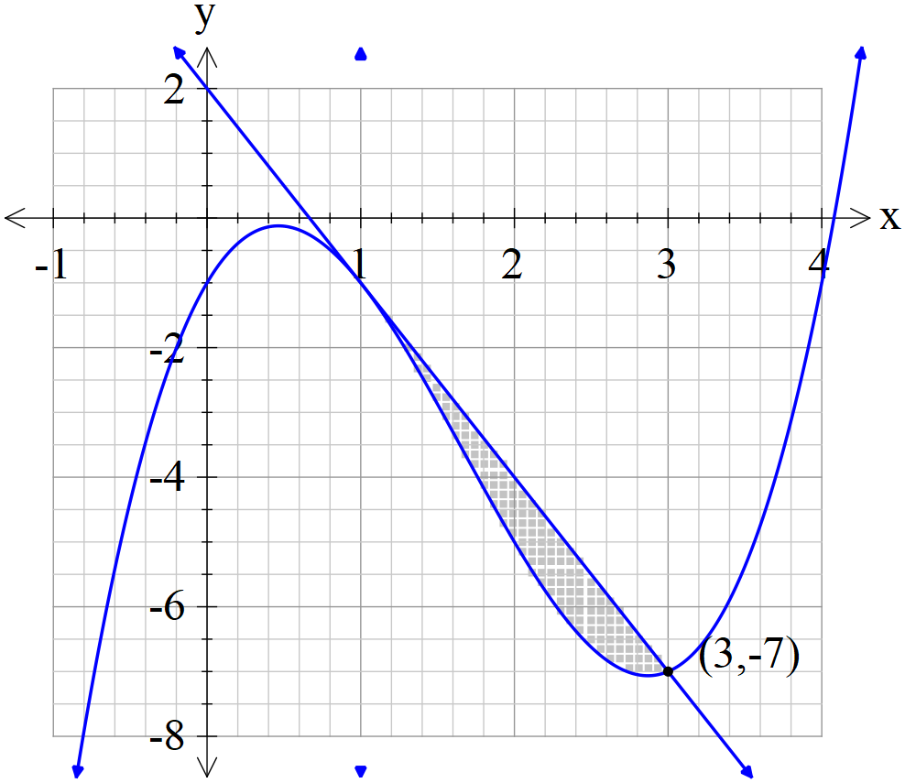

1. Determine the shaded area. (Exact) (3 marks)

| **Solution** |
| --- |
|  |
| **Specific behaviours** |
| ✓ determines tangent line  ✓ sets up integral for area  ✓ determines exact area |

The shaded area is then revolved around the x axis.

1. Determine the exact volume of the resulting solid. (4 marks)

| **Solution** |
| --- |
| Absolute value |
| **Specific behaviours** |
| ✓ uses correct integral  ✓ determines volume of outer curve  ✓ determines volume of inner curve  ✓ determines exact volume (no need for units) |

**Question 12 (7 marks)**

A super-heated metal rod cools according to the differential equation where is a constant representing the room temperature and is a constant. represents the temperature of the rod in degrees at time seconds that the rod has been left in the room,



1. Determine an expression for the temperature at **any time** in terms of and the constants. (4 marks)



| **Solution** |
| --- |
|  |
| **Specific behaviours** |
| ✓ uses separation of variables  ✓ uses ln(absolute value)  ✓ examines 2 cases compared to room temp  ✓ gives two expressions for T |

It is known that the room temperature is 18 degrees and that the initial temperature is 65 degrees and .



1. Determine the time taken for the temperature of the rod to cool to 32 degrees.

(3 marks)

| **Solution** |
| --- |
|  |
| **Specific behaviours** |
| ✓ solves for constant C  ✓ sets up equation for t  ✓ solves for t (no need for units) |

**Question 13 (7 marks)**

Consider the graph of the function as shown below.

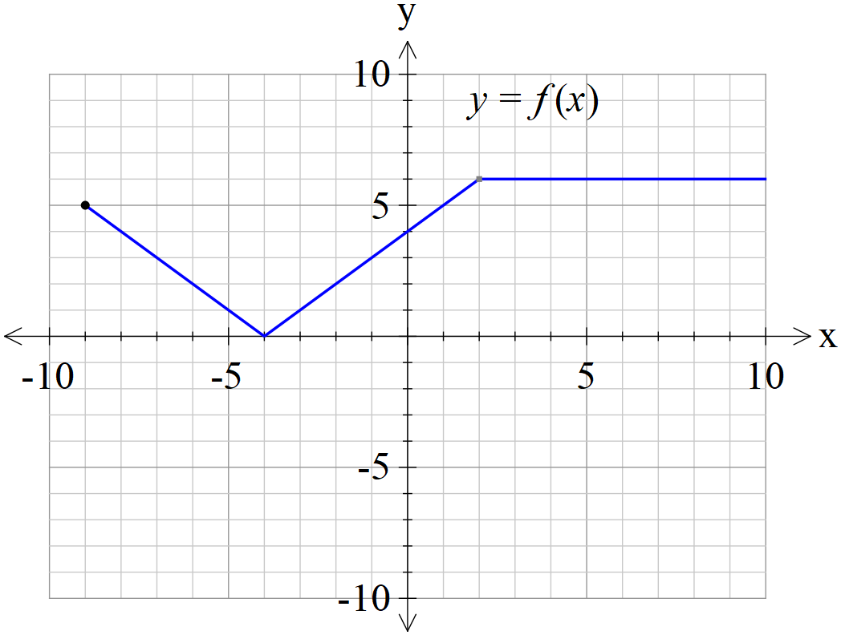

1. Sketch the graph on the axes below. (3 marks)



| **Solution** |
| --- |
|  |
| **Specific behaviours** |
| ✓ right side unchanged  ✓ y intercept correct  ✓ reflection of right side |

1. Sketch the graph on the axes below. (4 marks)



| **Solution** |
| --- |
|  |
| **Specific behaviours** |
| ✓ asymptote at x=4  ✓ asymptote at x=-4  ✓ x axis as asymptote and **only** drawn between x=-9 and x=9  ✓ symmetry about y axis |

**Question 14 (10 marks)**

An object with speed and displacement at time is moving with the following accelerations.



1. with at . Determine the speed at . (3 marks)



| **Solution** |
| --- |
| Speed is approx. 3.13 m/s |
| **Specific behaviours** |
| ✓ uses separation of variables  ✓ solves for constant  ✓ solves for and states positive speed (approx.) |

1. with at . Determine the speed at . (3 marks)



| **Solution** |
| --- |
| Speed = 5 |
| **Specific behaviours** |
| ✓ uses separation of variables  ✓ integrates exponential term  ✓ solves for constant and speed(states positive only) |

An object is known to be moving with **speed** given by the equation



.

1. If initially at the origin, determine the displacement from the origin, , at any time .



(Hint- use the substitution ) (4 marks)



| **Solution** |
| --- |
|  |
| **Specific behaviours** |
| ✓ uses separation of variables  ✓ uses u substitution  ✓ solves for constant  ✓ expresses x in terms of trig function of t. |

**Question 15 (9 marks)**

A particle moves according to the following parametric equations.

at time t seconds, in metres.



1. Determine the cartesian equation. (3 marks)

| **Solution** |
| --- |
|  |
| **Specific behaviours** |
| ✓ uses double angle formula for cosine  ✓ expresses sint in terms of y  ✓ obtains quadratic equation |

1. Determine the equation of the tangent when . (3 marks)



| **Solution** |
| --- |
|  |
| **Specific behaviours** |
| ✓ uses chain rule to find dy/dx  ✓ solves for constant  ✓ determines equation of tangent |

1. Determine when . (Simplify) (3 marks)



| **Solution** |
| --- |
|  |
| **Specific behaviours** |
| ✓ diff dy/dx with wrt t  ✓ divides by dx/dt  ✓ simplifies result |

**Question 16 (8 marks)**

A sample of 25 tyres are used to determine the population mean weight of the type of tyre.

The following 95% confidence interval was calculated kg.



1. Determine the sample mean. (1 mark)

| **Solution** |
| --- |
|  |
| **Specific behaviours** |
| ✓ determines midpoint of interval |

1. Determine the sample standard deviation. (3 marks)

| **Solution** |
| --- |
|  |
| **Specific behaviours** |
| ✓ determines z precentile  ✓ sets up equation for standard deviation  ✓ solves for standard deviation |

State whether the following changes would increase or decrease the width of the confidence interval and give a reason.

1. Have a sample size greater than 25 tyres. (1 mark)
2. Calculate a 90% confidence interval. (1 mark)
3. Using a smaller sample standard deviation. (1 mark)

| **Solution** |
| --- |
| 1. Decrease as width inversely prop to root n 2. Decrease as z percentile decreases 3. Decrease as width directly proportional |
| **Specific behaviours** |
| ✓ States decrease only for two points with no reason  ✓ States reason for two points  ✓ States decrease with an appropriate reason for all three points |

1. If 60 lots of 95% confidence interval were calculated, what number would you expect to contain the true population mean? (1 mark)

| **Solution** |
| --- |
|  |
| **Specific behaviours** |
| ✓ states correct number |

**Question 17 (8 marks)**

The position vector of a particle at time, seconds, is given by metres.



The path of the particle is shown as follows.

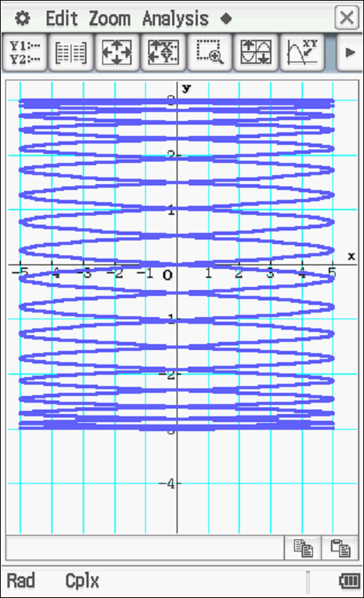

1. State the initial position and label on the path above. (1 mark)

| **Solution** |
| --- |
|  |
| **Specific behaviours** |
| ✓ Plots point on diagram |

1. Determine the acceleration when seconds. (3 marks)



| **Solution** |
| --- |
|  |
| **Specific behaviours** |
| ✓ determines velocity function  ✓ determines acceleration function  ✓ subs correct value of t |

1. Explain why the time of one complete circuit is seconds. (2 marks)



| **Solution** |
| --- |
|  |
| **Specific behaviours** |
| ✓ states period of each dimension  ✓ states LCM |

1. Determine the distance travelled in one circuit. (2 marks)

| **Solution** |
| --- |
|  |
| **Specific behaviours** |
| ✓ uses correct integral with speed  ✓ determines approx. distance in one interval |

**Question 18 (9 marks)**

1. Determine all positive values of the constant for the function so that will satisfy the differential equation . (3 marks)



| **Solution** |
| --- |
|  |
| **Specific behaviours** |
| ✓ sets up equation with exponentials  ✓ sets up quadratic equation for m  ✓ states positive value only as solution |

1. The section of the curve of the function in the interval is rotated about the x axis. Show that for the value of found in part a above, the volume of the solid produced after one rotation is. (3 marks)



| **Solution** |
| --- |
|  |
| **Specific behaviours** |
| ✓ uses volume of revolution integral  ✓ integrates correctly  ✓ determines correct expression for required m value |

1. Show that if the area under the curve in the interval , then . (3 marks)



| **Solution** |
| --- |
|  |
| **Specific behaviours** |
| ✓ integrates to determine area  ✓ obtains expression for exponential term in terms of A  ✓ obtains required expression. |

**Question 19 (7 marks)**

Two rockets A & B have initial position’s km at noon. They both move with constant velocities km/h.



1. The two rockets leave a smoke trail that stays in the air for a long period of time. Determine the point (if any) where the smoke trails cross. (3 marks)

| **Solution** |
| --- |
| Point (5,-1,-1)  But as this involves a negative time for one rocket, the smoke trials do not cross. |
| **Specific behaviours** |
| ✓ uses two variables  ✓ sets up simultaneous equations and solves for both variables  ✓ determines common point on both lines OR states that they do not cross |

1. Determine the shortest distance between the two rockets and the time that this occurs.

(4 marks)

| **Solution** |
| --- |
|  |
| **Specific behaviours** |
| ✓ uses relative velocity  ✓ obtains an expression for closest distance  ✓ uses dot product to solve for time  ✓ states both time and approx. closest distance |

**Question 20 (7 marks)**

Consider the quadrilateral with fixed side lengths . Let be opposite angles.

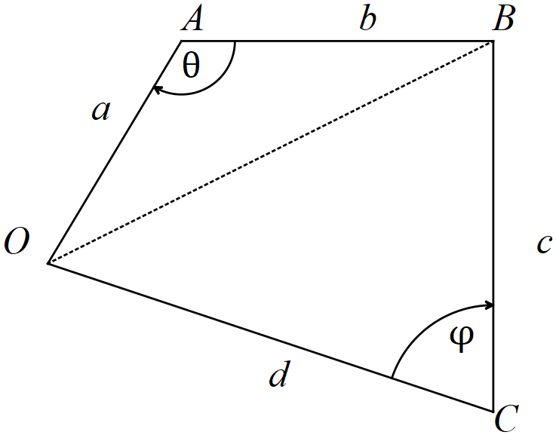

1. Show that the area of the quadrilateral is . (1 mark)



| **Solution** |
| --- |
| Uses sine rule for area for both triangles |
| **Specific behaviours** |
| ✓ uses areas sine rule for both triangles |

1. By considering the common side to both triangles above, show that .



(3 marks)

| **Solution** |
| --- |
|  |
| **Specific behaviours** |
| ✓ uses cosine rule for diagonal length OB  ✓ implicit diff of both sides wrt to one angle  ✓ obtains required expression |

1. Hence show **using calculus** that the area of the quadrilateral is optimal, , when opposite angles are supplementary, . (3 marks)



| **Solution** |
| --- |
|  |
| **Specific behaviours** |
| ✓ obtains first derivative using expression in part b  ✓ equates to zero and obtains an expression in terms of angles only  ✓ shows using compound formula for sine that angles must be supplementary |

**Additional working space**

Question number:

**Additional working space**

Question number:

**Additional working space**

Question number:

**Additional working space**

Question number: